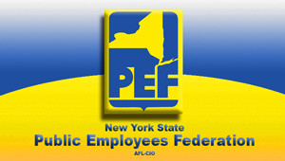
Public Employees Federation (PEF)
PEF Local 167 SCHOLARSHIP APPLICATION, 2025

 | DATE: | __________________________________________________________________________
 | APPLICANT NAME: | __________________________________________________________________________
 | ADDRESS: | __________________________________________________________________________
 | PEF DEPENDENT INFORMATION:
 | NAME OF PARENT: | __________________________________________________________________________
 | WORK LOCATION: | __________________________________________________________________________
 | NAME OF SCHOOL: | __________________________________________________________________________
 | COURSE OF STUDY: | __________________________________________________________________________
 | PROOF OF ENROLLMENT: | __________YES | __________NO
 | ESSAY QUESTION: | Please respond to the following question in paragraph form.  What does a Labor Union mean to me? Please use additional sheets of paper…..  _____________________________________________________________________________________________  _____________________________________________________________________________________________  _____________________________________ _____________________________________
Applications should be postmarked by July 16, 2025 to:
P.E.F. Division 167, 4300 Seneca Street, P.O. Box 582, West Seneca, NY 14224
D
DATE RECEIVED: _______________________________ DIVISION and/or COMMITTEE COMMENTS: ____________________________________

